# hemEmpirical Approach for Business Behavior Analysis in Business Process Management

## Definition of a system

“A system is collection of interrelated components that work together to perform a specific task or a goal”. In a system, the different components are connected with each other and they are interdependent.

Ex: ATM Machine System

* Customer
* ATM Machine (Hardware/Software)
* Bank Card
* Bank
* Card Reader

Specific Task: Withdraw Money

Ex: Java Institute System

* Lecturers
* Staff (Different Departments)
* Students
* Course Content
* Building

Specific Task: Training New Software Engineers

## What is System Boundary?

A system usually interacts with the external world or environment. The system boundary separates the system from its environment.

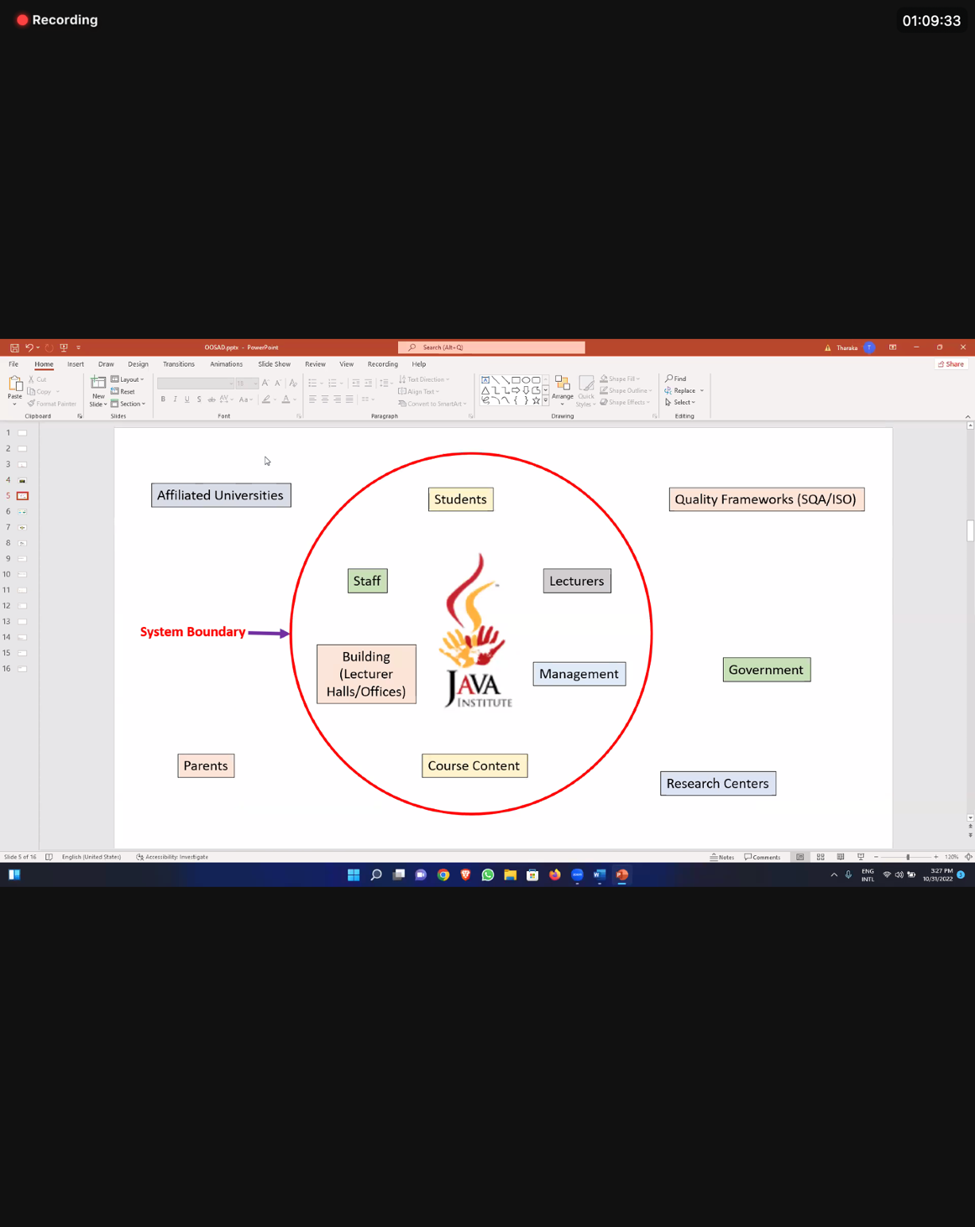A system boundary tells us what is inside and what is outside the system.

### Important System Concepts

* Decomposition – breaking down a system into smaller constitutes.
* Modularity – the result of decomposition parts of a system.
* Coupling. – dependencies between subsystems. එක subsystem ​එකක් තව එකක් එක්ක කොච්චර depend ​වෙනවද කියන එක.
* Cohesion – extent to which a subsystem performs a single function. Subsystem එකක් කොච්චර තනියම depend වෙනවද කියල.